**UNIT- IV Multipath Mitigation Techniques Part – A**

1. What is the need of equalization? **(Remembering)**

Equalization can be used to compensate the Inter Symbol Interference created by multipath within time dispersion channel.

1. Can you recall the principle of diversity? **(Remembering)**

The principle of diversity is to ensure that the same information reaches the receiver on Statistically independent channels.

1. Define zero forcing equalizer. **(Remembering)**

In a zero Forcing Equalizer, the equalizer coefficients Cn are chosen to force the samples of the combined channel and equalizer impulse response to zero at all but one of the NT spaced sample points in the tapped delay line filter.

1. How least mean square algorithm used in equalization techniques?

**(Remembering)**

The LMS equalizer maximizes the signal to distortion at its output within the constraints of the equalizer filter length.

1. List the techniques used to improve the received signal quality.

**(Remembering)**

Equalization, Diversity and Channel coding.

1. Relate the factors used in adaptive algorithms. (**Understanding**)
   1. Rate of convergence
   2. Misadjustments iii)computational complexity
2. Differentiate between macro and micro diversity. (**Understanding**)

|  |  |  |
| --- | --- | --- |
| S.No | Micro diversity | Macro diversity |
| 1. | Used to reduce small scale  fading effects. | Used to reduce large scale fading  effects. |
| 2. | Multiple reflections causes deep  fading. This effect is reduced. | Deep shadow causes fading.This  effect is reduced. |
| 3. | BS-MS are separated by a small  distance. | BS-MS are separated by a Large  distance. |

1. Give the advantages of LMS algorithm. **(Remembering)**
   1. The LMS equalizer maximizes the signal to distortion at its output within the constraints of the equalizer filter length.
   2. Low computational complexity’.
   3. Simple program.
2. Express the correlation coefficient of diversity. **(Remembering)**

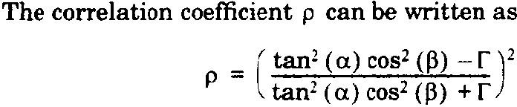

1. Draw the block diagram of a RAKE receiver. **(Remembering)**

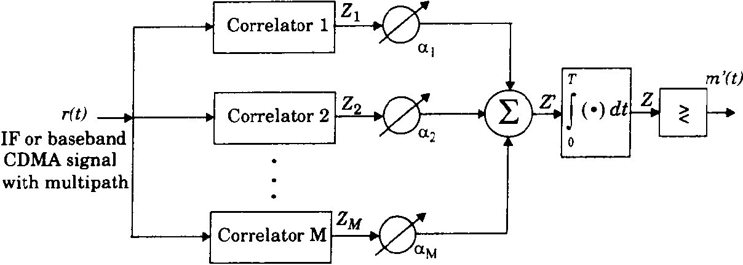

1. Classify the diversity and its combining techniques. **(Remembering)**

Micro Diversity and Macro Diversity. Combining Techniques-Selection Combining, Switched Combining, Equal gain combining and Maximum ratio combining.

1. Compare and contrast linear equalizers and non linear equalizers.

**(Remembering)**

**Linear equalizers:**

1. In linear equalizer, the current and past values of the received signal are linearly weighted by the filter coefficients and summed to produce the output. No feedback path is used.
2. Simple, easy to implement.
3. Not suitable for severely distorted channel, noise power signal is enhanced.

**Non Linear equalizers:**

1. If the past decisions are correct, then the ISI contributed by present symbol can be cancelled exactly, feedback path is used.
2. Suitable for severely distorted channel, also noise power is not enhanced.
3. Complex in structure, Channels with low SNR, the DFE suffers from error propagation.
4. Write about MMSE decision feedback equalizer. **(Remembering)**

MMSE decision feedback equalizer is a non linear equalization technique, which operates on minimizing the mean square error.

1. Why non linear equalizers are preferred? Justify. **(Remembering)**

The linear equalizers are very effective in equalizing channels where ISI is not severe. The severity of ISI is directly related to the Spectral characteristics. In this case there are spectral nulls in the transfer function of the effective channel; the additive noise at the receiver input will be dramatically enhanced by the linear equalizer. To overcome this problem, non linear equalizers can be used.

1. State the significance of linear and decision feedback equalizer.

**(Remembering)**

Linear Equalizers are very effective in equalizing channels where ISI is not severe. The addition noise at the receiver input is dramatically enhanced by the linear equalizer. The basic idea of Decision Feedback equalization is that once an information symbol has been detected and decided,the ISI that it induces on future symbols can be estimated and subtracted out before detection of subsequent symbols.

1. Design the structure of maximum like hood sequence estimator (MLSE) in nonlinear equalizer**. (Creating)**

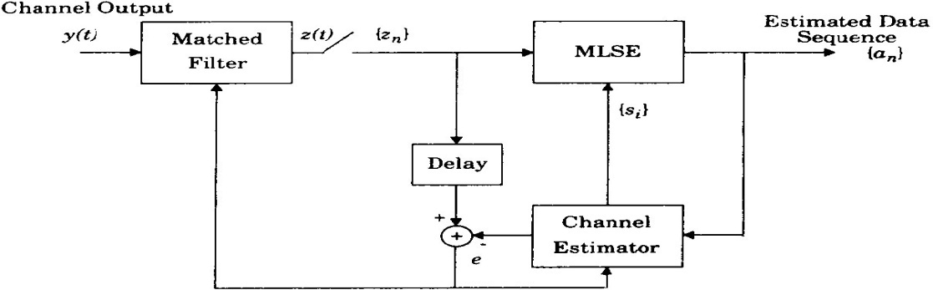

1. What is Diversity? **(Remembering)**

Diversity is used to compensate for fading channel impairments and is usually implemented by using two or more receiving antennas.

Diversity improves transmission performance by making use of more than one independently faded version of the transmitted signal.

1. What is Equalization? **(Remembering)**

Equalization can be used to compensate the Inter Symbol Interference created by multipath within time dispersion channel.

1. State the principle of diversity. **(Remembering)**

The principle of diversity is to ensure that the same information reaches the receiver on Statistically independent channels.

1. What is Transmit diversity? **(Remembering)**

Diversity effect is achieved by transmitting signals from several transmitting antenna is known as transmit diversity.

1. What is an equalizer? **(Remembering)**

Equalizer is a linear pulse shaping filter, used to reduce the effect of ISI.